本次试验基于原来的变量,对2010-2015年的数据进行建模,结果相比于97-15较好,原因在于华为数据基本上都是在05到15的区间上,在具体计算时会产生偏差.最后由于没有16年数据

所以将他设为-1,所以显得最后误差较大.

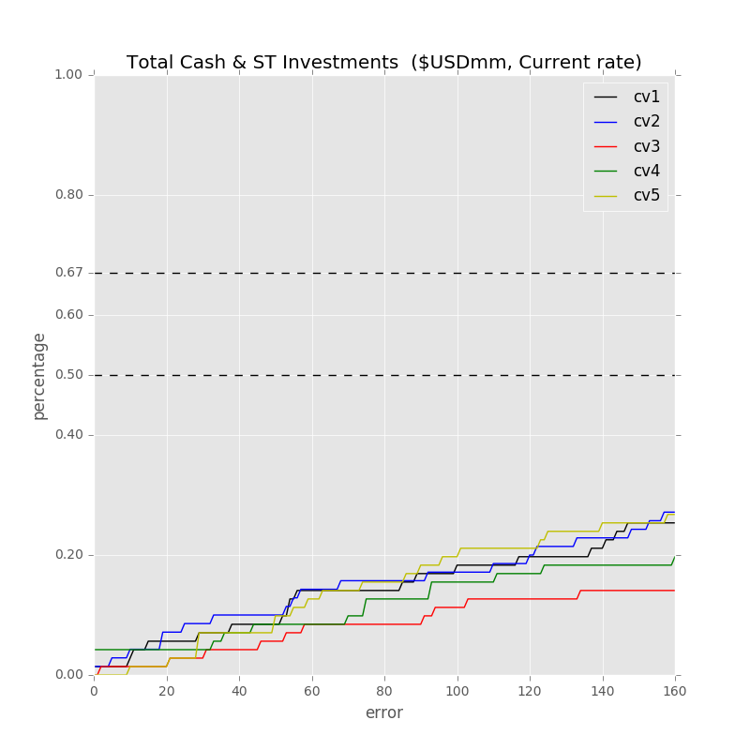

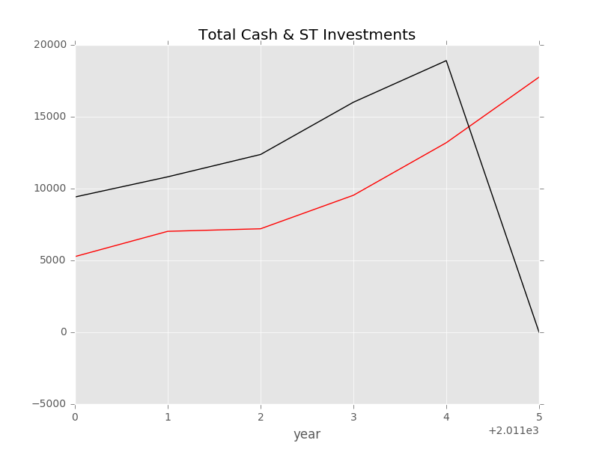

Label: Total Cash & ST Investments [FY 2011] ($USDmm, Current rate)

Min Error: 3793.888062

Mean Error: 7176.780858

Median Error: 5441.836687

Max Error: 17759.936889

Feature importance:

Rev YOY % [FY2010]: 0.035989

Cash from Ops./EBITDA % [FY 2010]: 0.030623

Net Property, Plant & Equipment/ Total Assets % [FY 2010]: 0.030327

Cash from Ops. [FY 2010] ($USDmm, Current rate): 0.030087

Cash from Ops./Net Income% [FY 2010]: 0.029873

Avg. Cash Conversion Cycle [FY 2010] (Days): 0.029565

Return on Equity % [FY 2010]: 0.029246

Net Income [FY 2010] ($USDmm, Current rate): 0.029091

Cash Acquisitions [FY 2010]($USDmm, Current rate): 0.029052

Capital Expenditure [FY 2010] ($USDmm, Current rate): 0.028969

Repurchase of Common Stock [FY 2010]($USDmm, Current rate): 0.028174

Capex/Rev %[FY 2010]: 0.027807

EBITDA [FY 2010] ($USDmm, Current rate): 0.027657

Total Asset Turnover [FY 2010]: 0.027461

Total Liabilities/Total Assets % [FY 2010]: 0.026973

Avg. Days Payable Out. [FY 2010] (Days): 0.026492

Other Operating Exp. Total [FY 2010] ($USDmm, Current rate): 0.026416

Total Assets [FY 2010] ($USDmm, Current rate): 0.026125

Net Income Margin % [FY 2010]: 0.025749

Avg. Days Sales Out. [FY 2010] (Days): 0.025143

EBITDA Margin % [FY 2010]: 0.025066

Cost Of Goods Sold [FY 2010] ($USDmm, Current rate): 0.024816

Return on Assets % [FY 2010]: 0.024811

Total Revenue [FY 2010] ($USDmm, Current rate): 0.023900

Gross Margin % [FY 2010]: 0.023557

Depreciation & Amort., Total [FY 2010] ($USDmm, Current rate): 0.023209

Total Liabilities [FY 2010] ($USDmm, Current rate): 0.023197

Goodwill/Total Asset % [FY 2010]: 0.023172

Goodwill/Total Revenue % [FY 2010]: 0.023145

Total Debt/Equity % [FY 2010]: 0.023043

R&D Exp. [FY 2010] ($USDmm, Current rate): 0.022559

Net Property, Plant & Equipment [FY 2010] ($USDmm, Current rate): 0.022534

Avg. Days Inventory Out. [FY 2010] (Days): 0.021959

Payout Ratio [FY 2010] (%): 0.021507

Cash Acquisitions/Total Revenue % [FY 2010]: 0.020936

Goodwill [FY 2010]($USDmm, Current rate): 0.019820

R&D Exp./Total Revenue % [FY 2010]: 0.016165

Year Founded: 0.015291

Number of Employees (Latest): 0.011357

cash flow risk: 0.009673

准入资本市场难度: 0.005822

Industry Dummy: 0.002328

Cash flow risk(0:low; 1: high): 0.001314

Total Min: 3793.888062

Total Mean: 7176.780858

Total Median: 5441.836687

Total Max: 17759.936889

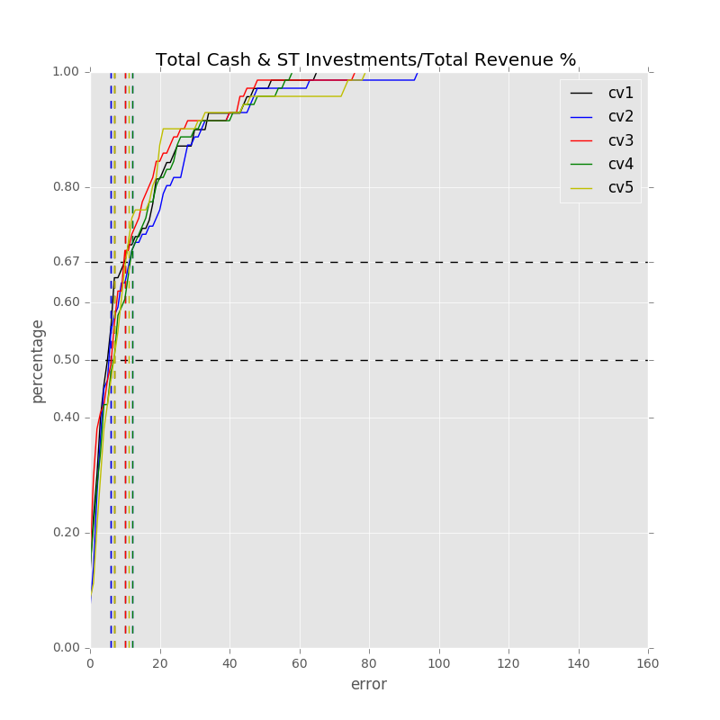

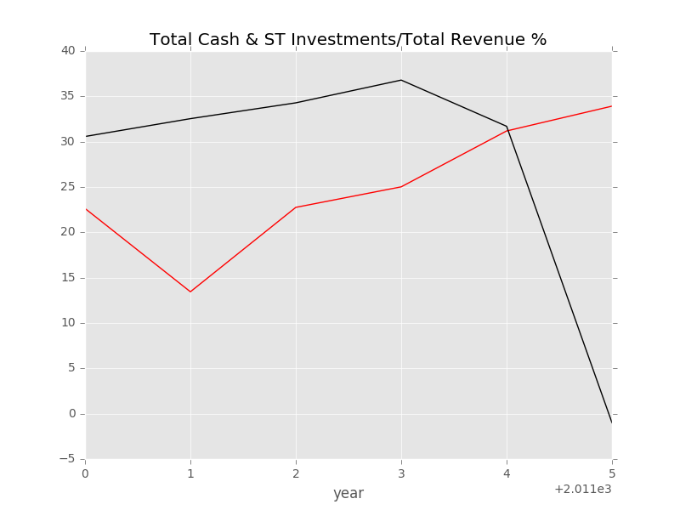

Label: Total Cash & ST Investments/Total Revenue % [FY 2011]

Min Error: 0.516258

Mean Error: 14.294387

Median Error: 11.651680

Max Error: 34.917250

Feature importance:

Cash from Ops./EBITDA % [FY 2010]: 0.037227

Rev YOY % [FY2010]: 0.034111

Return on Equity % [FY 2010]: 0.031744

Avg. Cash Conversion Cycle [FY 2010] (Days): 0.031469

Repurchase of Common Stock [FY 2010]($USDmm, Current rate): 0.028396

Gross Margin % [FY 2010]: 0.028330

Avg. Days Payable Out. [FY 2010] (Days): 0.027985

Return on Assets % [FY 2010]: 0.027984

Cash Acquisitions/Total Revenue % [FY 2010]: 0.027575

Cash from Ops./Net Income% [FY 2010]: 0.027478

Capex/Rev %[FY 2010]: 0.027051

Net Property, Plant & Equipment/ Total Assets % [FY 2010]: 0.027037

Capital Expenditure [FY 2010] ($USDmm, Current rate): 0.026766

Total Asset Turnover [FY 2010]: 0.026728

Avg. Days Sales Out. [FY 2010] (Days): 0.026558

Net Income Margin % [FY 2010]: 0.026283

Total Liabilities/Total Assets % [FY 2010]: 0.026215

Cash from Ops. [FY 2010] ($USDmm, Current rate): 0.026076

Depreciation & Amort., Total [FY 2010] ($USDmm, Current rate): 0.025410

Net Income [FY 2010] ($USDmm, Current rate): 0.025270

Other Operating Exp. Total [FY 2010] ($USDmm, Current rate): 0.024803

Net Property, Plant & Equipment [FY 2010] ($USDmm, Current rate): 0.024164

Cost Of Goods Sold [FY 2010] ($USDmm, Current rate): 0.023819

Cash Acquisitions [FY 2010]($USDmm, Current rate): 0.023720

Goodwill [FY 2010]($USDmm, Current rate): 0.023421

EBITDA [FY 2010] ($USDmm, Current rate): 0.023192

EBITDA Margin % [FY 2010]: 0.023170

Total Revenue [FY 2010] ($USDmm, Current rate): 0.023048

Payout Ratio [FY 2010] (%): 0.022819

Total Debt/Equity % [FY 2010]: 0.022745

Total Assets [FY 2010] ($USDmm, Current rate): 0.022480

Avg. Days Inventory Out. [FY 2010] (Days): 0.021508

Goodwill/Total Asset % [FY 2010]: 0.021398

Goodwill/Total Revenue % [FY 2010]: 0.021318

R&D Exp./Total Revenue % [FY 2010]: 0.021277

Total Liabilities [FY 2010] ($USDmm, Current rate): 0.020509

R&D Exp. [FY 2010] ($USDmm, Current rate): 0.018260

Year Founded: 0.017275

cash flow risk: 0.013333

Number of Employees (Latest): 0.012499

准入资本市场难度: 0.005416

Industry Dummy: 0.002255

Cash flow risk(0:low; 1: high): 0.001879

Total Min: 0.516258

Total Mean: 14.294387

Total Median: 11.651680

Total Max: 34.917250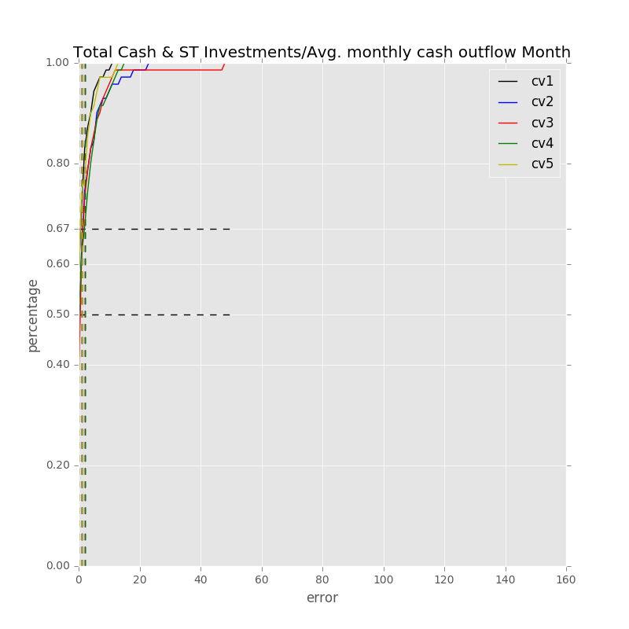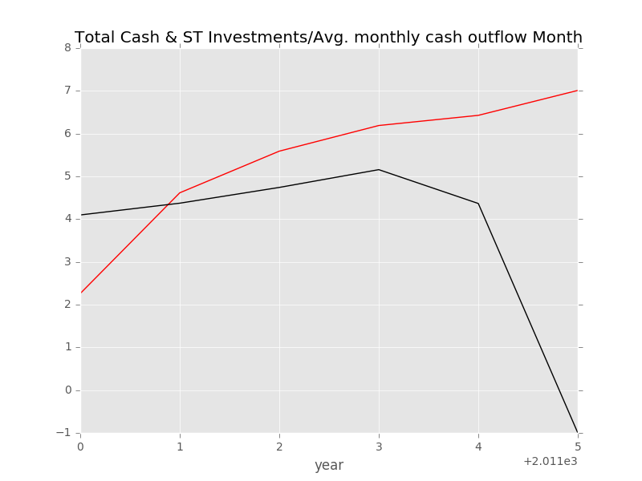

Label: Total Cash & ST Investments/Avg. monthly cash outflow Month[FY 2011]

Min Error: 0.242892

Mean Error: 2.338602

Median Error: 1.434644

Max Error: 8.009979

Feature importance:

Cash from Ops./EBITDA % [FY 2010]: 0.035440

Cash from Ops./Net Income% [FY 2010]: 0.033166

Rev YOY % [FY2010]: 0.032701

Total Liabilities/Total Assets % [FY 2010]: 0.032223

Avg. Cash Conversion Cycle [FY 2010] (Days): 0.031310

Return on Assets % [FY 2010]: 0.031045

Net Income Margin % [FY 2010]: 0.030824

Cash Acquisitions [FY 2010]($USDmm, Current rate): 0.030339

EBITDA Margin % [FY 2010]: 0.030200

Avg. Days Payable Out. [FY 2010] (Days): 0.029735

Return on Equity % [FY 2010]: 0.029180

Capex/Rev %[FY 2010]: 0.028481

Cash Acquisitions/Total Revenue % [FY 2010]: 0.028032

Total Asset Turnover [FY 2010]: 0.027288

Repurchase of Common Stock [FY 2010]($USDmm, Current rate): 0.027207

Net Property, Plant & Equipment/ Total Assets % [FY 2010]: 0.026892

Avg. Days Sales Out. [FY 2010] (Days): 0.026781

Gross Margin % [FY 2010]: 0.025292

Cash from Ops. [FY 2010] ($USDmm, Current rate): 0.024734

Other Operating Exp. Total [FY 2010] ($USDmm, Current rate): 0.024246

Total Debt/Equity % [FY 2010]: 0.023726

Net Property, Plant & Equipment [FY 2010] ($USDmm, Current rate): 0.023497

Payout Ratio [FY 2010] (%): 0.023435

R&D Exp./Total Revenue % [FY 2010]: 0.023413

Avg. Days Inventory Out. [FY 2010] (Days): 0.023255

Capital Expenditure [FY 2010] ($USDmm, Current rate): 0.022723

EBITDA [FY 2010] ($USDmm, Current rate): 0.022644

Total Liabilities [FY 2010] ($USDmm, Current rate): 0.022340

Goodwill/Total Revenue % [FY 2010]: 0.022255

Goodwill/Total Asset % [FY 2010]: 0.022179

Net Income [FY 2010] ($USDmm, Current rate): 0.022141

Depreciation & Amort., Total [FY 2010] ($USDmm, Current rate): 0.021731

Total Assets [FY 2010] ($USDmm, Current rate): 0.021158

Cost Of Goods Sold [FY 2010] ($USDmm, Current rate): 0.020994

Total Revenue [FY 2010] ($USDmm, Current rate): 0.019425

Goodwill [FY 2010]($USDmm, Current rate): 0.018766

R&D Exp. [FY 2010] ($USDmm, Current rate): 0.016446

Year Founded: 0.014003

Number of Employees (Latest): 0.012143

cash flow risk: 0.010578

准入资本市场难度: 0.003819

Industry Dummy: 0.002420

Cash flow risk(0:low; 1: high): 0.001791

Total Min: 0.242892

Total Mean: 2.338602

Total Median: 1.434644

Total Max: 8.009979

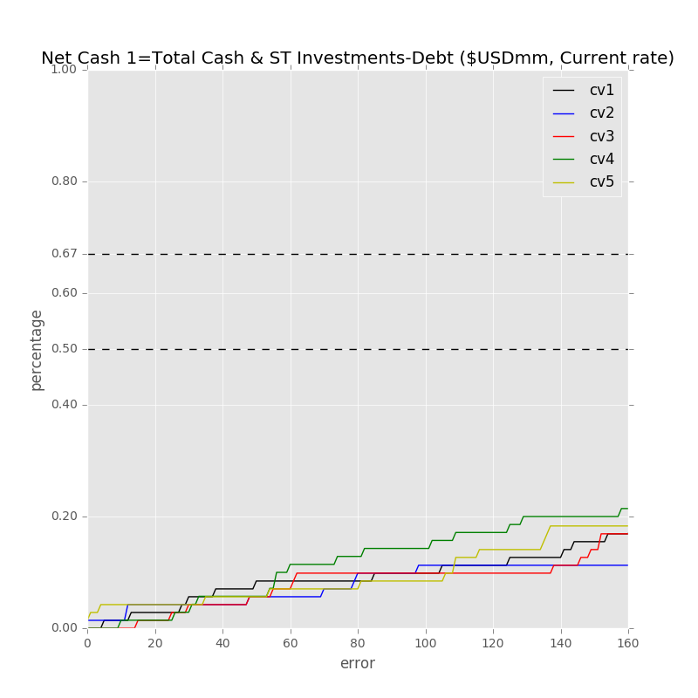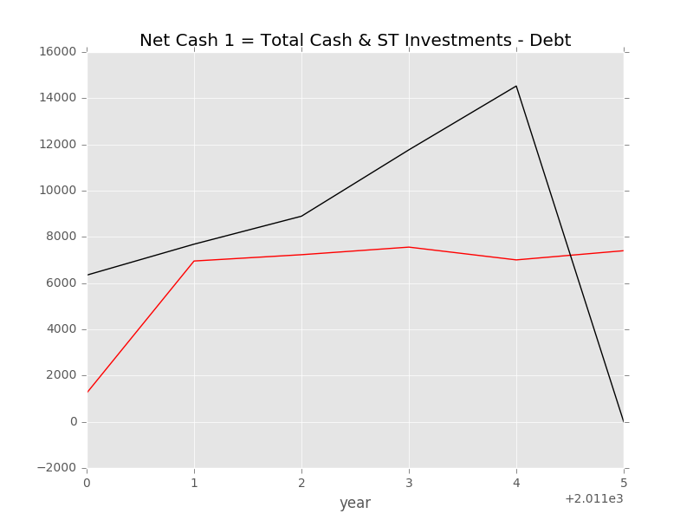

Label: Net Cash 1=Total Cash & ST Investments-Debt [FY 2011]($USDmm, Current rate)

Min Error: 728.310125

Mean Error: 4439.086723

Median Error: 4656.659263

Max Error: 7523.960097

Feature importance:

Rev YOY % [FY2010]: 0.033873

Cash from Ops./EBITDA % [FY 2010]: 0.032622

Net Income [FY 2010] ($USDmm, Current rate): 0.032207

Capex/Rev %[FY 2010]: 0.031781

Cash from Ops. [FY 2010] ($USDmm, Current rate): 0.030690

Cash from Ops./Net Income% [FY 2010]: 0.029124

Avg. Cash Conversion Cycle [FY 2010] (Days): 0.029062

Avg. Days Payable Out. [FY 2010] (Days): 0.028629

Net Property, Plant & Equipment/ Total Assets % [FY 2010]: 0.028311

Return on Assets % [FY 2010]: 0.028141

Total Asset Turnover [FY 2010]: 0.027625

Total Liabilities/Total Assets % [FY 2010]: 0.027004

Total Debt/Equity % [FY 2010]: 0.026754

Goodwill/Total Asset % [FY 2010]: 0.026566

Capital Expenditure [FY 2010] ($USDmm, Current rate): 0.026282

Other Operating Exp. Total [FY 2010] ($USDmm, Current rate): 0.026271

Total Assets [FY 2010] ($USDmm, Current rate): 0.026104

Avg. Days Sales Out. [FY 2010] (Days): 0.026015

Cash Acquisitions [FY 2010]($USDmm, Current rate): 0.025904

Return on Equity % [FY 2010]: 0.025648

EBITDA [FY 2010] ($USDmm, Current rate): 0.025556

Repurchase of Common Stock [FY 2010]($USDmm, Current rate): 0.024957

Cash Acquisitions/Total Revenue % [FY 2010]: 0.024906

Cost Of Goods Sold [FY 2010] ($USDmm, Current rate): 0.024473

Payout Ratio [FY 2010] (%): 0.023811

Gross Margin % [FY 2010]: 0.023809

Depreciation & Amort., Total [FY 2010] ($USDmm, Current rate): 0.023597

Avg. Days Inventory Out. [FY 2010] (Days): 0.023589

Net Income Margin % [FY 2010]: 0.023274

Total Revenue [FY 2010] ($USDmm, Current rate): 0.023250

EBITDA Margin % [FY 2010]: 0.022704

Net Property, Plant & Equipment [FY 2010] ($USDmm, Current rate): 0.022542

Total Liabilities [FY 2010] ($USDmm, Current rate): 0.021878

Goodwill [FY 2010]($USDmm, Current rate): 0.021434

Goodwill/Total Revenue % [FY 2010]: 0.021216

R&D Exp. [FY 2010] ($USDmm, Current rate): 0.020335

R&D Exp./Total Revenue % [FY 2010]: 0.016056

Year Founded: 0.014338

Number of Employees (Latest): 0.012746

cash flow risk: 0.009645

准入资本市场难度: 0.003249

Industry Dummy: 0.002460

Cash flow risk(0:low; 1: high): 0.001560

Total Min: 728.310125

Total Mean: 4439.086723

Total Median: 4656.659263

Total Max: 7523.960097

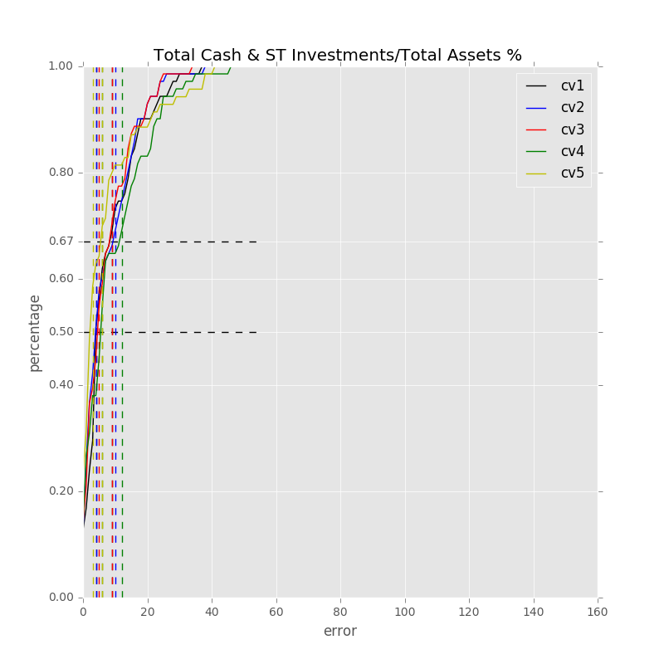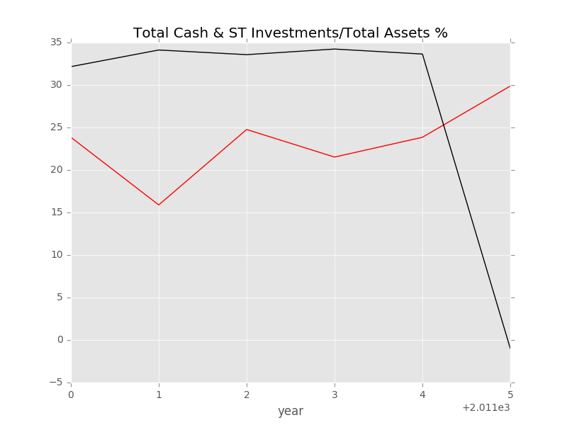

Label: Total Cash & ST Investments/Total Assets % [FY 2011]

Min Error: 8.312467

Mean Error: 14.787461

Median Error: 11.251812

Max Error: 30.876563

Feature importance:

Rev YOY % [FY2010]: 0.033958

Capex/Rev %[FY 2010]: 0.032823

Cash from Ops./EBITDA % [FY 2010]: 0.032461

Return on Equity % [FY 2010]: 0.030689

Cash from Ops./Net Income% [FY 2010]: 0.030006

Return on Assets % [FY 2010]: 0.029417

Net Property, Plant & Equipment/ Total Assets % [FY 2010]: 0.028248

Avg. Cash Conversion Cycle [FY 2010] (Days): 0.027983

Total Asset Turnover [FY 2010]: 0.027517

EBITDA Margin % [FY 2010]: 0.027215

Avg. Days Sales Out. [FY 2010] (Days): 0.027159

Net Income [FY 2010] ($USDmm, Current rate): 0.027040

Repurchase of Common Stock [FY 2010]($USDmm, Current rate): 0.026682

Avg. Days Payable Out. [FY 2010] (Days): 0.026450

Cash Acquisitions [FY 2010]($USDmm, Current rate): 0.026362

Gross Margin % [FY 2010]: 0.026052

Total Liabilities/Total Assets % [FY 2010]: 0.025388

Avg. Days Inventory Out. [FY 2010] (Days): 0.025239

Cash from Ops. [FY 2010] ($USDmm, Current rate): 0.025166

Payout Ratio [FY 2010] (%): 0.024778

EBITDA [FY 2010] ($USDmm, Current rate): 0.024770

Net Income Margin % [FY 2010]: 0.024735

Goodwill/Total Asset % [FY 2010]: 0.024588

Capital Expenditure [FY 2010] ($USDmm, Current rate): 0.024448

Total Debt/Equity % [FY 2010]: 0.024211

Cash Acquisitions/Total Revenue % [FY 2010]: 0.023577

Cost Of Goods Sold [FY 2010] ($USDmm, Current rate): 0.023521

Total Liabilities [FY 2010] ($USDmm, Current rate): 0.023403

Depreciation & Amort., Total [FY 2010] ($USDmm, Current rate): 0.023026

Goodwill/Total Revenue % [FY 2010]: 0.022362

Total Assets [FY 2010] ($USDmm, Current rate): 0.022216

Total Revenue [FY 2010] ($USDmm, Current rate): 0.022071

Other Operating Exp. Total [FY 2010] ($USDmm, Current rate): 0.021973

R&D Exp./Total Revenue % [FY 2010]: 0.021664

Net Property, Plant & Equipment [FY 2010] ($USDmm, Current rate): 0.021232

Goodwill [FY 2010]($USDmm, Current rate): 0.020958

R&D Exp. [FY 2010] ($USDmm, Current rate): 0.017169

Year Founded: 0.016422

Number of Employees (Latest): 0.015091

cash flow risk: 0.012225

准入资本市场难度: 0.004688

Industry Dummy: 0.002867

Cash flow risk(0:low; 1: high): 0.002150

Total Min: 8.312467

Total Mean: 14.787461

Total Median: 11.251812

Total Max: 30.876563

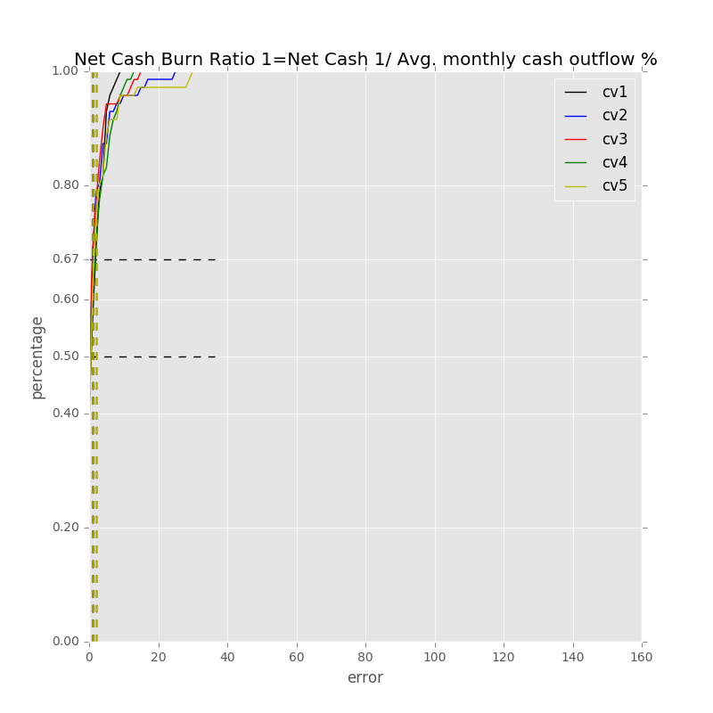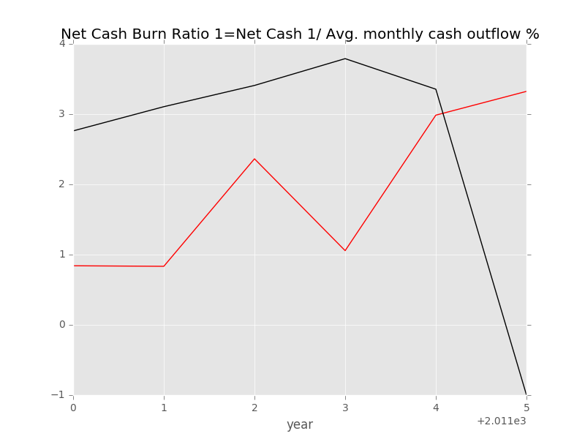

Label: Net Cash Burn Ratio 1=Net Cash 1/ Avg. monthly cash outflow %[FY 2011]

Min Error: 0.369734

Mean Error: 2.110812

Median Error: 2.096302

Max Error: 4.324360

Feature importance:

Rev YOY % [FY2010]: 0.034312

Cash from Ops./EBITDA % [FY 2010]: 0.033275

Cash from Ops./Net Income% [FY 2010]: 0.031573

Total Liabilities/Total Assets % [FY 2010]: 0.031360

Total Asset Turnover [FY 2010]: 0.031061

Total Debt/Equity % [FY 2010]: 0.029135

Net Property, Plant & Equipment/ Total Assets % [FY 2010]: 0.029076

Capex/Rev %[FY 2010]: 0.028563

Avg. Cash Conversion Cycle [FY 2010] (Days): 0.028449

Avg. Days Sales Out. [FY 2010] (Days): 0.027693

Return on Equity % [FY 2010]: 0.027573

Return on Assets % [FY 2010]: 0.027233

Avg. Days Payable Out. [FY 2010] (Days): 0.027075

Goodwill/Total Asset % [FY 2010]: 0.027049

Net Income Margin % [FY 2010]: 0.026907

Cash Acquisitions/Total Revenue % [FY 2010]: 0.026848

Capital Expenditure [FY 2010] ($USDmm, Current rate): 0.026511

EBITDA [FY 2010] ($USDmm, Current rate): 0.026010

Payout Ratio [FY 2010] (%): 0.025952

EBITDA Margin % [FY 2010]: 0.025461

Net Property, Plant & Equipment [FY 2010] ($USDmm, Current rate): 0.025162

Cash from Ops. [FY 2010] ($USDmm, Current rate): 0.024876

Gross Margin % [FY 2010]: 0.024778

Cash Acquisitions [FY 2010]($USDmm, Current rate): 0.024601

Avg. Days Inventory Out. [FY 2010] (Days): 0.024268

Cost Of Goods Sold [FY 2010] ($USDmm, Current rate): 0.024254

Net Income [FY 2010] ($USDmm, Current rate): 0.023928

Repurchase of Common Stock [FY 2010]($USDmm, Current rate): 0.023370

Goodwill/Total Revenue % [FY 2010]: 0.023224

Other Operating Exp. Total [FY 2010] ($USDmm, Current rate): 0.022433

Total Assets [FY 2010] ($USDmm, Current rate): 0.022221

Total Liabilities [FY 2010] ($USDmm, Current rate): 0.021677

Total Revenue [FY 2010] ($USDmm, Current rate): 0.021378

R&D Exp./Total Revenue % [FY 2010]: 0.020822

Depreciation & Amort., Total [FY 2010] ($USDmm, Current rate): 0.020303

Goodwill [FY 2010]($USDmm, Current rate): 0.019848

R&D Exp. [FY 2010] ($USDmm, Current rate): 0.016896

Year Founded: 0.014227

cash flow risk: 0.011293

Number of Employees (Latest): 0.009532

准入资本市场难度: 0.006101

Industry Dummy: 0.002166

Cash flow risk(0:low; 1: high): 0.001525

Total Min: 0.369734

Total Mean: 2.110812

Total Median: 2.096302

Total Max: 4.324360

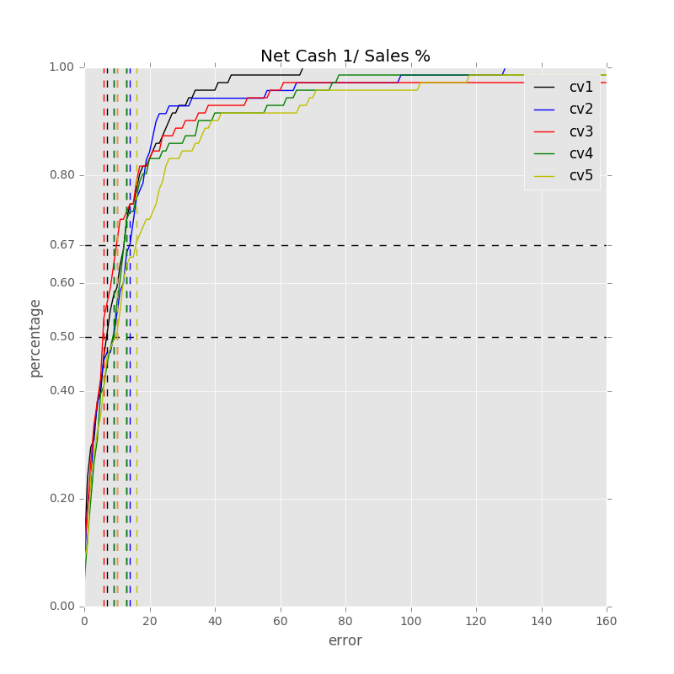

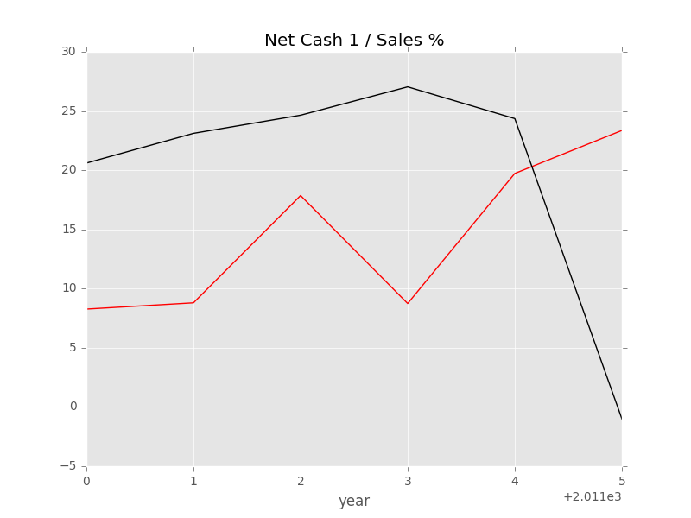

Label: Net Cash 1/ Sales %[FY 2011]

Min Error: 4.631479

Mean Error: 13.453754

Median Error: 13.323440

Max Error: 24.357666

Feature importance:

Avg. Cash Conversion Cycle [FY 2010] (Days): 0.036102

Total Liabilities/Total Assets % [FY 2010]: 0.033891

Total Asset Turnover [FY 2010]: 0.033417

Rev YOY % [FY2010]: 0.032186

Avg. Days Sales Out. [FY 2010] (Days): 0.030703

Net Property, Plant & Equipment/ Total Assets % [FY 2010]: 0.030407

Capex/Rev %[FY 2010]: 0.030011

Return on Equity % [FY 2010]: 0.029872

Avg. Days Payable Out. [FY 2010] (Days): 0.029630

Return on Assets % [FY 2010]: 0.028883

Cash from Ops./Net Income% [FY 2010]: 0.028780

Total Liabilities [FY 2010] ($USDmm, Current rate): 0.028109

Cash from Ops./EBITDA % [FY 2010]: 0.027814

Goodwill/Total Asset % [FY 2010]: 0.027449

Net Income Margin % [FY 2010]: 0.027319

Repurchase of Common Stock [FY 2010]($USDmm, Current rate): 0.026888

EBITDA Margin % [FY 2010]: 0.025718

Capital Expenditure [FY 2010] ($USDmm, Current rate): 0.025686

Net Income [FY 2010] ($USDmm, Current rate): 0.025658

Other Operating Exp. Total [FY 2010] ($USDmm, Current rate): 0.025633

Total Debt/Equity % [FY 2010]: 0.025566

Net Property, Plant & Equipment [FY 2010] ($USDmm, Current rate): 0.024260

Gross Margin % [FY 2010]: 0.023969

Goodwill/Total Revenue % [FY 2010]: 0.023945

Cash Acquisitions/Total Revenue % [FY 2010]: 0.023909

Cost Of Goods Sold [FY 2010] ($USDmm, Current rate): 0.023421

Avg. Days Inventory Out. [FY 2010] (Days): 0.022763

EBITDA [FY 2010] ($USDmm, Current rate): 0.022649

Cash Acquisitions [FY 2010]($USDmm, Current rate): 0.022475

Cash from Ops. [FY 2010] ($USDmm, Current rate): 0.022350

Total Assets [FY 2010] ($USDmm, Current rate): 0.022208

Depreciation & Amort., Total [FY 2010] ($USDmm, Current rate): 0.021075

Total Revenue [FY 2010] ($USDmm, Current rate): 0.020630

Payout Ratio [FY 2010] (%): 0.019785

Goodwill [FY 2010]($USDmm, Current rate): 0.019192

R&D Exp. [FY 2010] ($USDmm, Current rate): 0.018825

R&D Exp./Total Revenue % [FY 2010]: 0.017054

Year Founded: 0.013606

Number of Employees (Latest): 0.011624

cash flow risk: 0.010247

准入资本市场难度: 0.002982

Industry Dummy: 0.001767

Cash flow risk(0:low; 1: high): 0.001543

Total Min: 4.631479

Total Mean: 13.453754

Total Median: 13.323440

Total Max: 24.357666